**Human-Computer Interaction (UE18CS348)**

**Car Control Application**

**Final Project Report**

**Team Members**

Sunad Suhas (PES2201800511) (Section A)

Vishnu Anand (PES2201800067) (Section F)

Sahithya Papireddy (PES2201800086) (Section A)

Khushdeep Kaur (PES2201800063) (Section F)

**Problem Statement**

**An Android Application to control your car**

The aim of this project is to explore the capabilities of Android Studio to quickly develop mobile applications for a given purpose.

The chosen context is the creation of an app that allows the user to remotely control his/her connected car in order to-

* locate it
* lock/unlock the doors/trunk
* activate the air conditioner and define its temperature
* honk or activate the lights
* check its status (temperature, warnings, etc.)

Although it is not meant to be used in a real-case scenario, the developed application passed the initial implementation phases, including a user evaluation executed in order to seek further improvement windows.

Final considerations for future work are also provided.

**Introduction**

This report was produced in order to make known the process of development of the Car Control Application*.* The document covers the description of the task proposed to us and the solution implemented by us within the human-computer interaction curricular unit using the concepts absorbed throughout the semester. In addition to the information, a brief listing of the biggest implementation problems we encounter and the achievements we have achieved over the development period is also presented.

The reader is expected to complete reading this report with a general idea of the methods we use for the production of the application. In addition, we aim to make known the tools that gave the basis of the application and all the features implemented in it.

**Requirements Analysis**

It is general knowledge the importance of a good analysis of the characteristics of the problem and the intended objectives so that the final result is an effectively useful product. With this in mind, our group has devoted the recommended time to collecting the necessary information and planning the work to be done.

For the development of the requirements analysis, we use the characterization of users, elaborating *a persona* (which faithfully represented the type of audience that would be interested in the final product of this project), as well as some scenarios of use of the application. An in-depth description of this process was described in the previous report, however we left here a *short summary of the persona,* in order to contextualize the reader.

**User characterization:**

Philip, a 41-year-old economist living in California, married and the father of two young people, is a very busy man. Now, with his recent promotion, he values his time more than ever and always seeks to make time for his family.

Given his professional field, Joaquim looks a lot to the financial side of everything, trying to save whenever he can. The option to buy an electric car came to him when he realized the two goods he would take from this choice: a great savings in consumption and the ecological value associated with the car.

After buying his first-hand electric and modern car, the economist feels very pleased with its acquisition. Impressed by the comfort and innovation that the car brought him, and being a passionate about the technologies, Joaquim wonders if there would be any mobile phone application that would complement his new car, further increasing its efficiency. Having access to certain features of the car through your mobile phone seems very interesting to a person like him.

At the end of this phase of information collection and planning, we have reached the conclusion of the following Aspects:

- General idea of the complete *layout* of the application;

- Ideal platform for implementation;

- Design appealing to the target *audience;*

- Limits on the connection of the application to a vehicle.

Regarding the prototype created, it should be noted that its construction was of low fidelity. The use of paper for the construction of this prototype aimed to lead to tests done by users allow them to be as sincere as possible and give as much feedback as they could. The final result of this paper prototype is presented in the figures below:

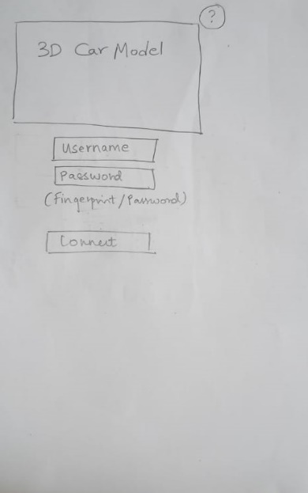 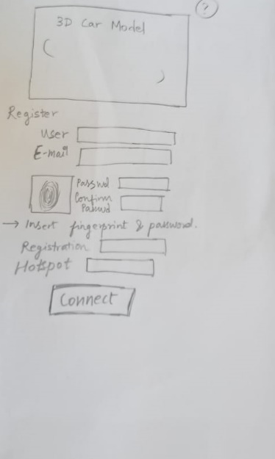 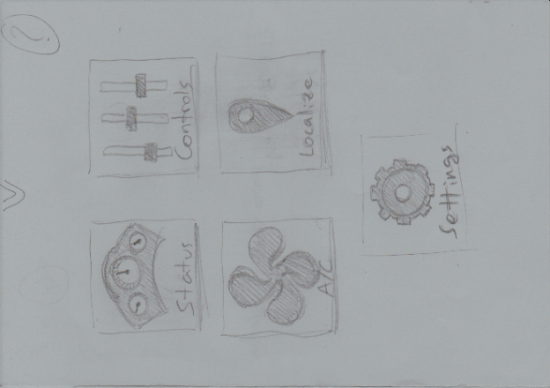

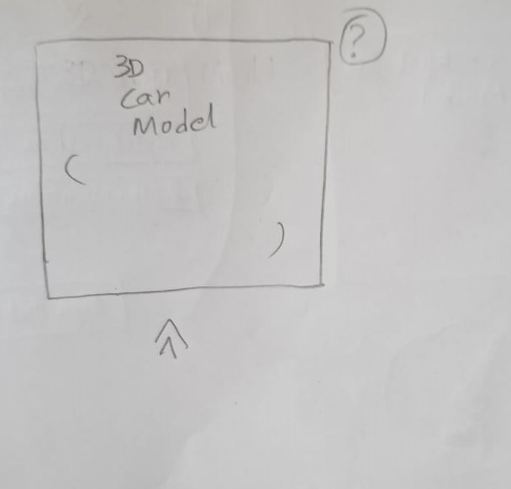 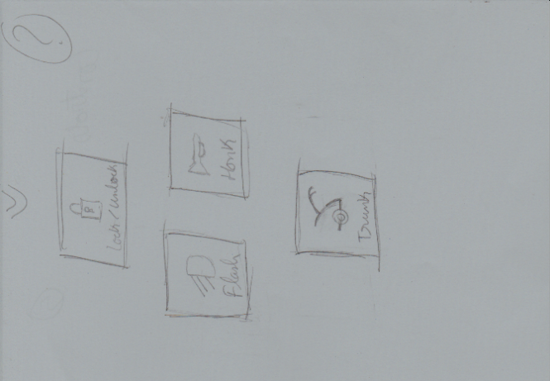

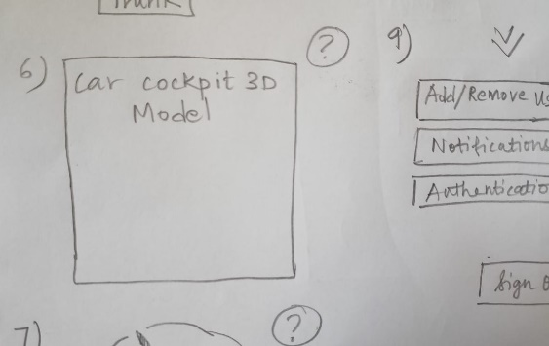

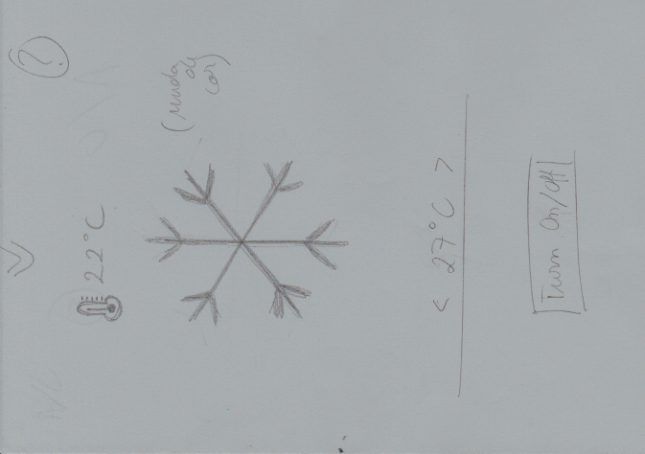 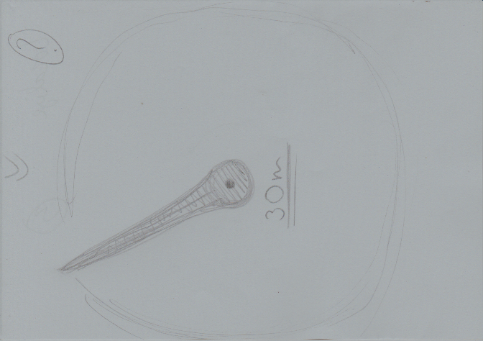 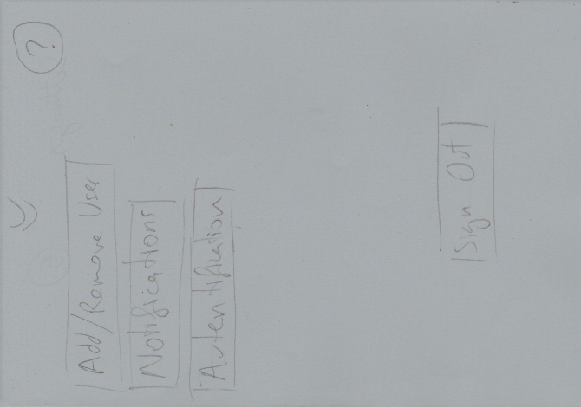

This prototype was subject to change after a few discussions with my fellow friends, although in only a few details. It was also at this stage that we were proposed several new features that could be interesting for such an application and which we took into account before moving on to the next stage.

**Implementation**

In the second stage of the project, already with a prototype of the consolidated application, as well as the use cases and the target audience (through a characteristic *persona)* defined, we proceeded then to the construction of the Application *Car Control*.

In this document is made available the set of textures created by us (through image editing tools such as Photoshop) for the application. It should be noted that they are all our own, in order to always maintain a visual consistency in the application.

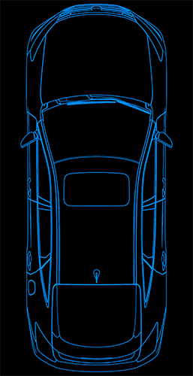 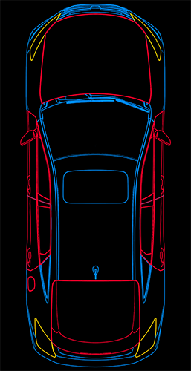



     

Using the *Android Studio programming tool,* we divide the application by sections, each with a well-defined purpose. The reason we chose this development tool Is mainly because there were no disagreements of any element involved with this project in how an application like Car Control App would only make sense to exist if it were accessible via mobile phone. Thus, given that Android is the most common mobile operating system nowadays and that the backend programming language used by Android Studio is Java (which we are already quite used to dealing with), the choice of the base operating system was natural to us.

Among the features implemented during this development phase, we can enumerate the following:

- *Expandable list* (scroll within a page, used to present additional options);

- *Interior activities* (modal on top of the current page, used for an informative purpose);

- *Tint variation* (used to change the color of an image according to the value decided by the user);

- *Angle variation with rotation vector* (used to simulate the location of the vehicle);

- *Visibility* (used to show content depending on the value of certain parameters);

- *Toast messages* (used to give feedback to the user when performing an action);

- *Swipe* (used as a way to navigate the application);

- *Login validation* (verification of validity of user input)

- Etc.

**Heuristic Evaluation**

Moving on to the third stage of development, we have organized a usability test to our application.

The scenario of performing the tasks had a minimum complexity, being only necessary to make available to the participants a smartphone with the application installed. Participants were aware that all tests performed through the application would have no effect on any real car and that they would only be to simulate the operation of the application. The tasks consisted of: the participant should validate himself when entering the application (with data provided by us) and would have the opportunity to navigate the application to understand it and solve the problems presented to him; the participant also had as objectives to manipulate the air conditioning of his car, locate it and check the condition of the vehicle. After the test, the participants answered a questionnaire whose objective was to help us collect data to improve the usability of the application.

At the end of these tests and questionnaires and after analyzing their results, we found that on average participants found the application:

- easy and pleasant to navigate and find what you are looking for;

- fast and consistent;

- easy to read and with intuitive icons;

- with an attractive graphic appearance.

However, we also found that some participants:

- in certain tasks they felt the need to use the information *tab* (existing on each page of the application) to understand the purpose of the page;

- sometimes did not find the amount of information presented adequate

- Had the opinion that certain more important features should have a better highlight.

Graph 1 – study of the presence of usability principles in the application, based on the data collected in the tasks of the usability test and in the post-task questionnaire through an interpretation of our relationship between the answers given and heuristics. The evaluation is made from 0 to 4, where 0 means no usability problem and 4 has the meaning of total catastrophe.

– legend:

VES = System State Visibility

CSMR = System-Real-World Correspondence

CLU = User Control and Freedom

CS = Consistency and Standards

PE = Error Prevention

RR = Recognition instead of Remembrance

FEU = Flexibility and Efficiency in Use

EDM = Aesthetics and Minimalist Design

ARDRE = Help in Error Recognition, Diagnosis, and Recovery

AD = Help and Documentation

**Notes:**

- no participant refused to perform any of the tasks or to complete the post-task questionnaire

- the data of each participant were kept in total anonymity, as well as their results after the usability test

- it is important to make it clear that all participants attended the discipline with which this project is related, one of which was the teacher of the discipline

**The Application**

In the last stage of development, we proceeded to correct the inconsistencies still present in the implementation and to the implementation of details that would improve the weaknesses of the implementation. At this stage we took much into account the data collected in the usability test, as well as in all relevant recommendations given by the participants. Among the changes applied, the following stand out:

- transforming one of the menus into a main menu *sidebar*

- increased prominence of high-importance components (e.g.- vehicle autonomy)

- increased feedback on the execution of actions (e.g.- temperature change)

- improving the quality of information provided

- correction the choice of certain technical terms

- implementation of the additional feature of continuously pressing homepage alerts to directly access the pages of the respective controls

The screenshots of all the screens in the app are included below-

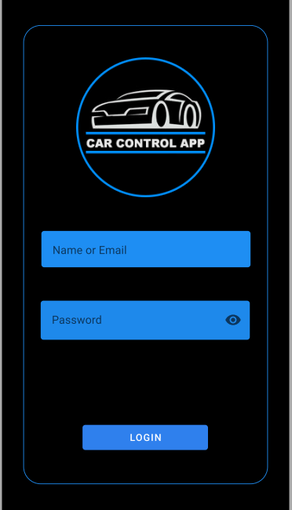

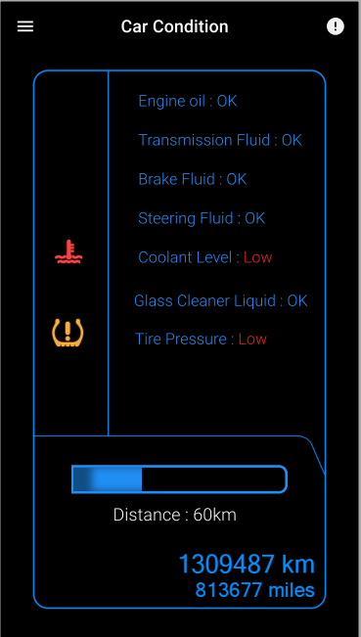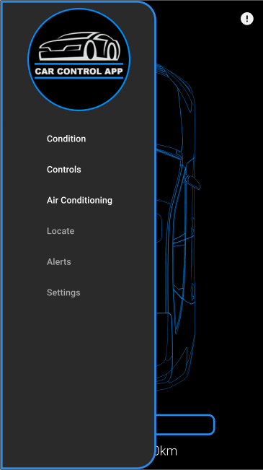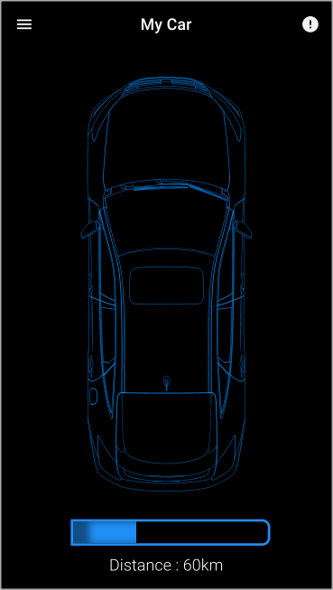

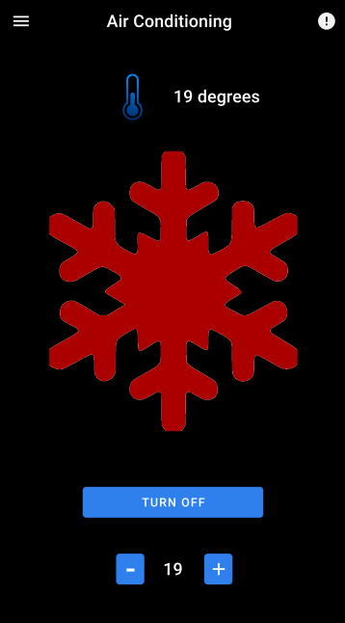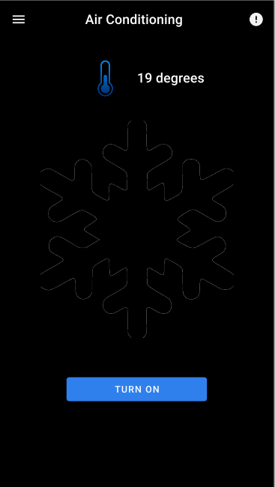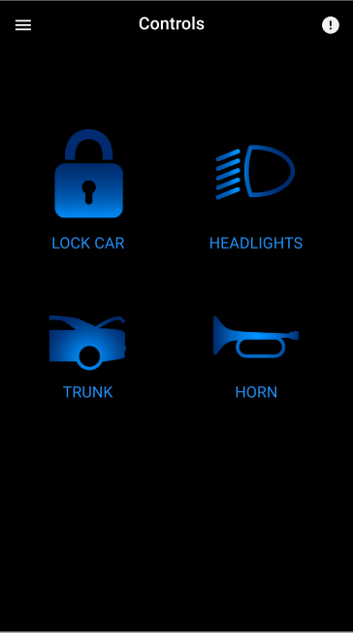

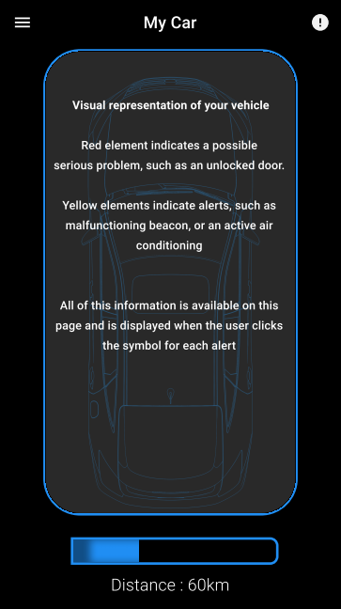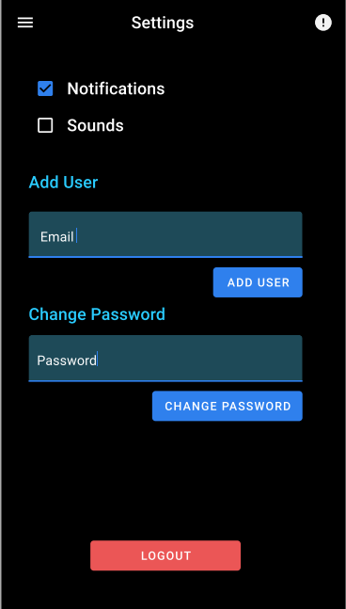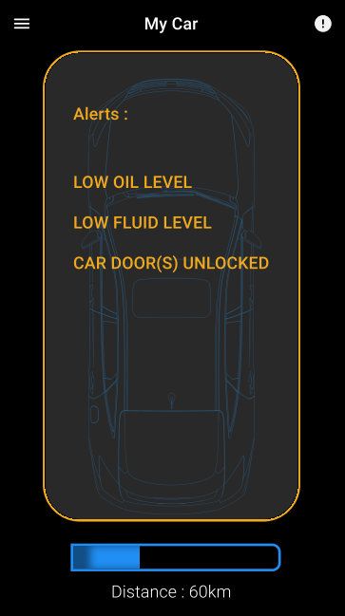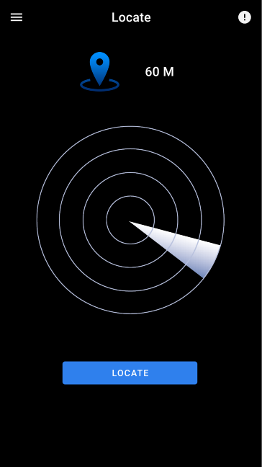

**Problems / Difficulties**

In a project of development of an application with interaction between computer and human it is necessary to have a very constant pace of work so that all problems that arise are faced in the best way. At this level we can say that we have not had many difficulties in keeping the objectives in mind and the goals within our reach.

However, we were not so lucky in the tool we used for the implementation of all features, *Android Studio*. Since all cases of using an application like these led us to a mobile *application,* we concluded that the most logical platform to use would be one that would allow the application to run on *smartphones.* This conclusion has brought us the problem of having to face a tool that we have never used before. After a time of adaptation, we understand that this tool has even brought us added value, so we are satisfied with its overall performance.

At the level of the features themselves, we can say that we have not faced many relevant difficulties but that we can mention some setbacks in the implementation of the gyroscope (on the Find page), the color gradient (on the AC page) and the memory management available for the application.

**Future Work**

Imagining a continuity of this final post-delivery project and an effective implementation of the application together with a car company, it would be necessary to take into account various aspects of both safety and compatibility and even the extensibility of the number of features available.

After an exchange of ideas, we came to the conclusion that future work in the development of the application would be:

- ensure the safety of the connection between the vehicle and the application

- establish direct access to a database with the current state of the vehicle and all users of the application with permission to access the vehicle

- allow access to the car's location at any time

- improve the functionality of notifications in aspects such as security and freedom of use by the user

- make it possible to choose the display of the vehicle either in a 2D model or in a 3D

- make available a wide list of languages for the application (starting with English)

**Conclusion**

By making a critical analysis of all stages of *the development of the Car Control App* and its final result, we can conclude that the main objectives of the project were met, within the established deadlines, with the robustness, simplicity and design we were looking for.

In our view, an application like this could be effectively implemented by a company that manufacturer of electric and non-electric cars and, taking into account the feedback of all the people who had the opportunity to try our final version, would succeed in the target audience. However, we are well aware that for such a project to be implemented, a set of changes to the application would be necessary that would be outside our reach and outside the scope of the curricular unit.

In terms of the performance and commitment of the members of the working group, we can say that they were quite positive, that there was a constant pace of work and a balanced distribution of tasks, taking advantage of the strengths of each element as best as possible. We can also say that we had a great pleasure in creating a mobile *application* and that we consider that the knowledge absorbed by us throughout this project will be an asset to us in the future.

**Search Sources:**

<https://elearning.ua.pt/course/view.php?id=97>

<https://stackoverflow.com/>

<https://www.tutorialspoint.com/human_computer_interface/guidelines_in_hci.htm>

<https://developer.apple.com/ios/human-interface-guidelines/overview/themes/>

<https://www.interaction-design.org/literature/book/the-encyclopedia-of-human-computer-interaction-2nd-ed/usability-evaluation>

<https://msdn.microsoft.com/en-us/library/dn688964.aspx>